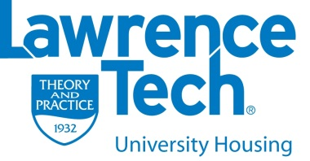
Resident Assistant
2023-2024 Dates to Remember

Applicant Info
Information Sessions
Early Bird: Wednesday, November 30th @ 9:00pm in Weast
Student Athlete Focused: Tuesday, December 6th @ 9:00pm in M218
All-Welcome: Wednesday December 7th @ 7:00pm in C406 (Welcome Center)
All-Welcome: Tuesday, January 10th January 10th @ 9:00pm in Weast
Last Call: Monday, January 23rd @ 9:00pm in Weast
Information Tables
December 1st 11am-1pm East Lobby
December 5th 11am-1pm Reuss Lobby
January 10th 11am-1pm Atrium
January 11th 11am-1pm Donley Lobby
January 13th 11am-1pm South Lobby

Resume Workshop
Thursday, January 12th 8:00pm M218 - Need to fix your resume? Don’t have a resume? We will help!

Programming Workshop
Thursday, January 19th 8:00pm M218- Learn about the programming that RAs complete for their residents and how to plan a successful program!

Conflict Management Workshop (invite only)
Thursday, January 26th 8:00pm M218- Learn about the frequent types of conflicts and issues RAs face in the residence halls and how to handle them successfully!

Application Due Date
Wednesday, January 25th @ 4:00pm. All items should be taken to the Housing Office, C404.
Late applications will not be accepted.

New Candidate Interviews
You will be notified of your interview time by Friday, January 27th at 4pm
Interviews will occur between January 30th-February 24th
Case Study Presentations
Returning Applicants: February 10th & 11th //New applicants: February 17th & 18th
Letters Sent Out
Friday, March 3rd. If you live on campus, please check your student mailbox!

Accept/Decline
Friday, March 17th
Deadline to accept or decline position – Letters due to the Office of University Housing by 4 p.m.

All Staff Meeting for 23-24 Staff
Sunday, April 9th -This is when you will meet your new staff!

